User manual (**Element wise Addition**)

/*

* Element wise Addition

* This CUDA code can handle/work with any type of the input mxArrays,

* GPUarray or standard matlab CPU array as input {prhs [0], prhs [1]:= mxGPUArray or CPU Array}

* GpuArray output, C= **ELM_CUDA** or **ELM_CUDA_3D** (A, B, alpha, beta) C=A*alpha+B*beta

* Developed at UCL, Institute of Neurology, 12 Queen Square, WC1N 3AR, London

* Welcome Trust Centre for Neuroimaging

* Part of the project SPM (http://www.fil.ion.ucl.ac.uk/spm)

* Copyright 2018

* Kevin Bronik

*/

Replacing Matlab operator “+” with parallel Matlab-CUDA syntax (with additional scaling options)

**Examples:**

**(First example**)

>> A 🡨--- (3D input array)

A(:,:,1) =

1 2 3

4 5 6

7 8 9

A(:,:,2) =

10 11 12

13 14 15

16 17 18

A(:,:,3) =

19 20 21

22 23 24

25 26 27

>> B 🡨--- (3D input array)

B(:,:,1) =

1 2 3

4 5 6

7 8 9

B(:,:,2) =

10 11 12

13 14 15

16 17 18

B(:,:,3) =

19 20 21

22 23 24

25 26 27

>> C=ELA_CUDA_3D (A, B, 1, 1) 🡨--- (Processing the addition) [C=A*1+B*1]

C(:,:,1) =

2 4 6

8 10 12

14 16 18

C(:,:,2) =

20 22 24

26 28 30

32 34 36

C(:,:,3) =

38 40 42

44 46 48

50 52 54

>> K=ELA_CUDA_3D (A, B, 2, -1) 🡨--- (Processing the addition) [K=A*2+B*(-1)]

K(:,:,1) =

1 2 3

4 5 6

7 8 9

K(:,:,2) =

10 11 12

13 14 15

16 17 18

K(:,:,3) =

19 20 21

22 23 24

25 26 27

>>

**(Second example**)

**3D image processing using element wise addition**

This example shows how to process two colour image using the three-dimensional Element wise Addition.

Read an image into the workspace, then convert the image to double.

[X,map] = imread('kotatko.tiff');

if ~isempty(map)

Im1 = ind2rgb(X,map);

end

[Y,map] = imread('water.tiff');

if ~isempty(map)

Im2 = ind2rgb(Y,map);

end

Perform an element wise addition of the colour images using the ELA_CUDA_3D function.

K = ELA_CUDA_3D (Im1, Im2, 0.5, 1);

Display the original colour image alongside the processed image.

figure

imshowpair(Im1,K,'montage')

title('Original colour image (Left) and processed image (Right)');

Name Size Bytes Class Attributes

Im1 310x517x3 (Image Dimensions) 3846480 double

Name Size Bytes Class Attributes

Im2 310x517x3 (Image Dimensions) 3846480 double

**Before processing:**

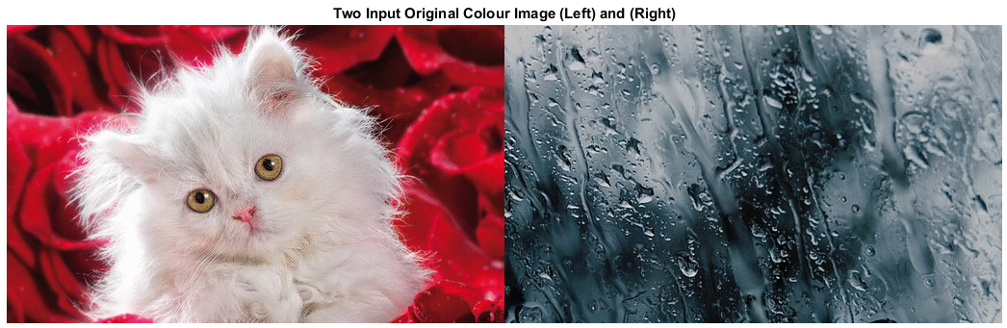{\displaystyle \left({\begin{array}{ccc}\mathrm {a} _{11}&\mathrm {a} _{12}&\mathrm {a} _{13}\\\mathrm {a} _{21}&\mathrm {a} _{22}&\mathrm {a} _{23}\\\mathrm {a} _{31}&\mathrm {a} _{32}&\mathrm {a} _{33}\end{array}}\right)\circ \left({\begin{array}{ccc}\mathrm {b} _{11}&\mathrm {b} _{12}&\mathrm {b} _{13}\\\mathrm {b} _{21}&\mathrm {b} _{22}&\mathrm {b} _{23}\\\mathrm {b} _{31}&\mathrm {b} _{32}&\mathrm {b} _{33}\end{array}}\right)=\left({\begin{array}{ccc}\mathrm {a} _{11}\,\mathrm {b} _{11}&\mathrm {a} _{12}\,\mathrm {b} _{12}&\mathrm {a} _{13}\,\mathrm {b} _{13}\\\mathrm {a} _{21}\,\mathrm {b} _{21}&\mathrm {a} _{22}\,\mathrm {b} _{22}&\mathrm {a} _{23}\,\mathrm {b} _{23}\\\mathrm {a} _{31}\,\mathrm {b} _{31}&\mathrm {a} _{32}\,\mathrm {b} _{32}&\mathrm {a} _{33}\,\mathrm {b} _{33}\end{array}}\right)}

**After processing: [**K = ELA_CUDA_3D (Im1, Im2, 0.5, 1);**]**

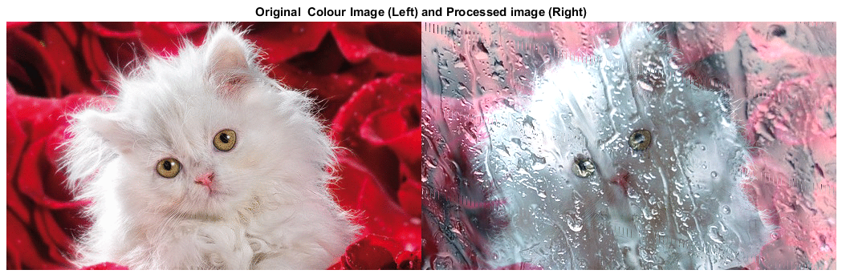

To compile:

First try the method described here:

<https://uk.mathworks.com/help/distcomp/run-mex-functions-containing-cuda-code.html>

After successful compiling running and testing then simply try following statement (copy and paste in Matlab and enter):

>> debug_ELA_CUDA_cu(false)

See the file “debug_ELA_CUDA_cu.m”